Software Engineering Assignment

Module: 1 (SDLC)

1).What is software? What is software engineering?

Software, is a collection of computer programs and related data that provide the instructions for telling a computer what to do and how to do it.

“Software engineering is the multi-person construction of multi-version software.

2). Explain types of software

System Software

System software provides the basic functions for computer usage and helps run the computer hardware and system.

Programming Software

Programming is the process of designing, writing, testing, debugging, and maintaining the source code of computer programs. This source code is written in a programming language. The purpose of programming is to create a program that exhibits a certain desired behavior.

Application Software

Application software is the general designation of computer programs for performing user tasks.

3).What is SDLC? Explain each phase of SDLC

SDLC is System Development Life cycle.

Planning :- (Programming flow)

Implementation :- (coding)

Testing :- ( debug ,csr)

Documentation :- srs document is used for implementing System.

Deployment :- Live on store (Play Store, App Store)

Support & maintenance :- maintenance of product

4).What is DFD? Create a DFD diagram on Flipkart

DFD- Data Flow Diagrams.

Graphical representation of flow of data inside application. Used for visualization and data processing.

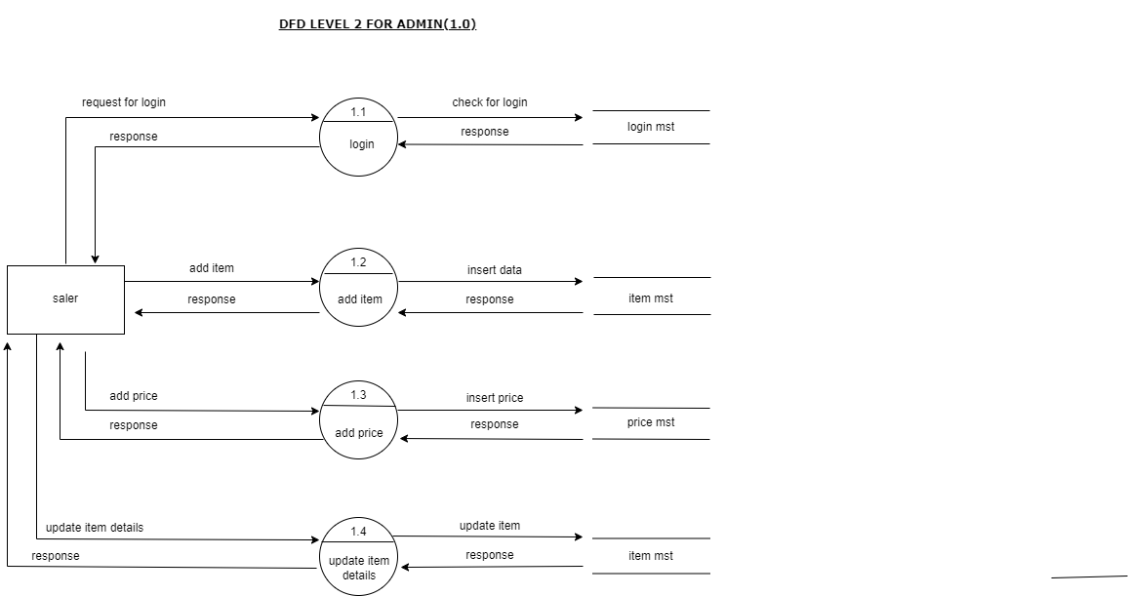

5).What is Flow chart? Create a flowchart to make addition of two numbers

Flowchart is graphical representation of a program.

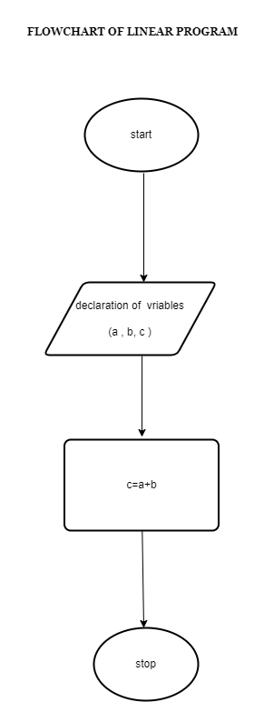

6).What is Use case Diagram? Create a use-case on bill payment on paytm.

Use-case diagrams **describe the high-level functions and scope of a system**. These diagrams also identify the interactions between the system and its actors.

